EXECUTIVE SUMMARY

- INTRODUCTION

- Audited Agency

The Mindanao State University- Tawi-Tawi College of Technology and Oceanography (MSU-TCTO) was formally established under Republic Act No. 6060, as amended, on August 4, 1969 in southern Sulu and it was known as the Sulu College of Technology and Oceanography and started its operation as an integral unit of the Mindanao State University. With the creation of the Province of Tawi-Tawi, the name was changed to Tawi-Tawi College of Technology and Oceanography on March 16, 1982, under Batas Pambansa Blg. 197.

Its primary mandate is to extend to the Muslims and other cultural minority groups (now communities) the opportunities of college education and develop such other programs that will promote Muslim welfare and hasten the economic development of the southernmost region of the Philippines.

The administration of the College and the exercise of its corporate powers are vested exclusively in the Board of Regents as constituted by law and the president of the College as authorized by the Board. Complementing and assisting the Chancellor in the educational thrust of the College are the Vice Chancellors for Academic Affairs, Research and Extension, and Administration and Finance.

- Audit Methodology

The audit was conducted in accordance with applicable legal and regulatory requirements, and the Philippine Public Sector Standards on Auditing. Those standards require that we plan and perform the audit to obtain a reasonable basis for our conclusions.

- Scope of Audit

The audit covered the accounts and operations of the MSU-TCTO for the Calendar Year 2016. It was aimed at ascertaining the propriety of financial transactions, Management’s compliance to prescribed rules and regulations and the fairness of presentation of the financial statements.

- FINANCIAL HIGHLIGHTS

- Comparative Financial Condition and Results of Operations

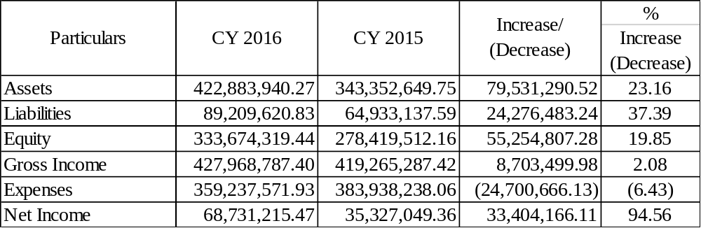

- Operational Highlights

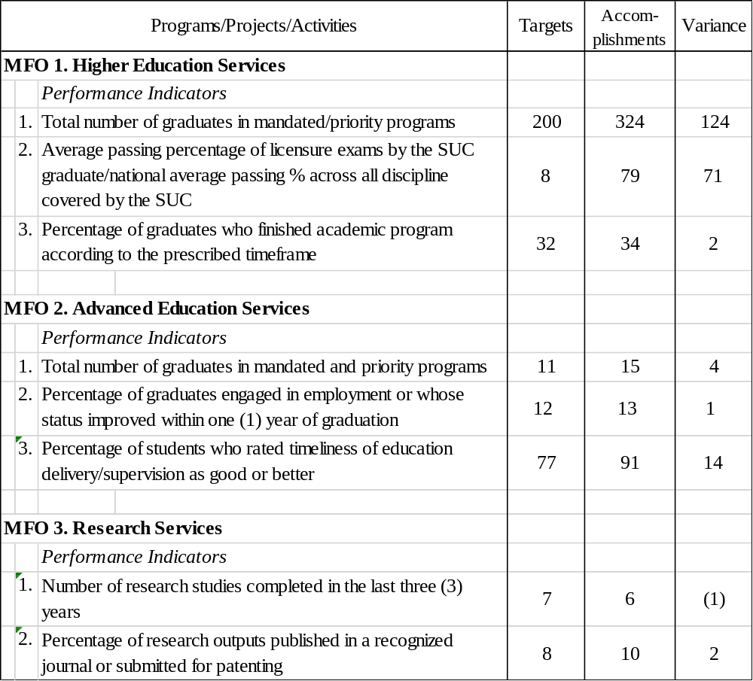

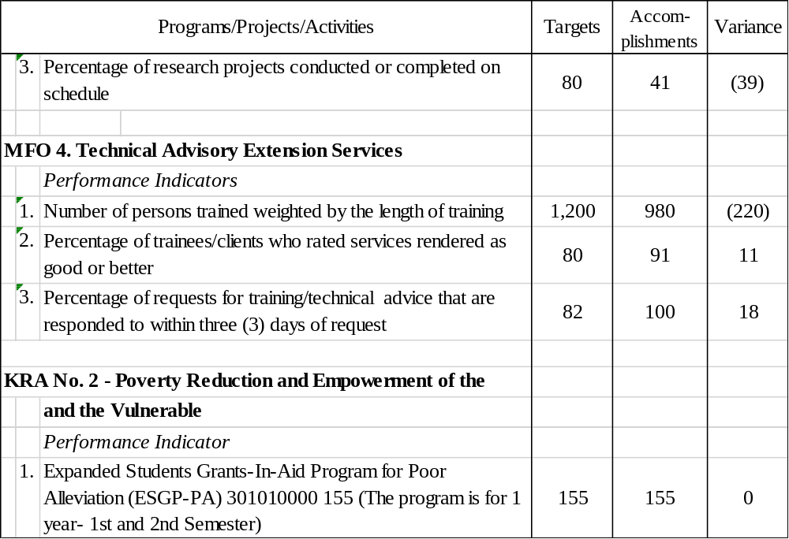

- AUDIT OPINION ON THE FINANCIAL STATEMENTS

The Auditor rendered an adverse opinion on the fairness of presentation of the financial statements due to the material effects of the noted deficiencies on some of the accounts, as discussed in detail in Part II of the report.

- SUMMARY OF SIGNIFICANT OBSERVATIONS AND RECOMMEN- DATIONS

- Unutilized Notice of Cash Allocation (NCAs) for CY 2016 and prior years totaling P 84,040,990.88 were not reverted to the Bureau of Treasury contrary to DBM Circular Letter No. 2013-12, DBM NBC No. 561 and Section 186 of GAAM, Volume 1, resulting in unreliable balances of Cash in Bank-Local Currency, Current Account (LCCA) as of year-end.

We recommend that Management shall:

- Require the Accountant to determine the actual unutilized NCA balances as of December 31, 2016.
- Direct the Accountant to remit the remaining unutilized NCA to the Bureau of Treasury.

- Comply with the provisions of DBM CL No. 2013-12 and DBM NBC No. 561 to present a reliable Cash in Bank balance.

- Management’s laxity in the enforcement of Section 16 of Executive Order No. 248, as amended, and its implementing rules and regulations provided in COA Circular No. 97-002 on cash advances granted for travel, resulted in the accumulation of un-liquidated cash advances of P 12,488,341.45, thus sizeable amount of current operating expenses are unrecorded.

We recommend the following measures:

- The Chancellor should refrain from approving Travel Order when notice is received from the Accountant that previous travel was not yet liquidated;
- Enforce withholding of salary of non-compliant personnel; and
- The Office of the Accountant should maintain up-to-date individual subsidiary ledgers for Due from Officers and Employees. This will facilitate monitoring of cash advances.

- Cash advances granted to regular and special disbursing officers of P 20,648,026.55 for the payment of other compensation and time-bound activities were allowed to remain not liquidated at the end of the year contrary to the provisions of Section 89 of PD 1445 and COA Circular No. 97-002 thus, expenses for personal services for the year were not recorded. And this resulted in the overstatement of the net income. Further, it exposed the funds to the risk of misuse and loss.

Demand from the concerned accountable officers the immediate liquidation of the cash advances. Direct the College Cashier to withhold the salaries of the concerned accountable officers who failed to liquidate their obligations within thirty (30) upon receipt of the demand letter.

- The College failed to conduct physical inventory and to submit the inventory report in Calendar Year 2016 as required under Section 490 of Government Accounting and Auditing Manual, Volume I, thus the validity, existence and correctness of the Supplies Inventory and Property, Plant and Equipment accounts with book value of P 9,135,517.63 and P 232,990,531.53, respectively, could not be ascertained affecting the fair presentation of the accounts in the financial statements.

We reiterate our recommendation for the Agency to conduct periodic physical inventory of its property, plant and equipment and a report thereon be immediately prepared and submitted to the Auditor not later than January 31 of each year. Items that are beyond economic repair shall be properly disposed and dropped from the books. The Property and Supplies Office/Unit should maintain Property Cards.

- Depreciation was not provided by the agency for its Property, Plant and Equipment with acquisition cost of P 270,345,395.32, hence, assets and net income for the year was overstated by about P 18,603,011.27.

Direct the Accountant and the Property and Supply Officer to exert effort to secure the documents necessary to reconstruct the PPE accounts so that depreciation for the current and previous years maybe computed to arrive at the correct valuation of the property, plant and equipment. In case the necessary data could no longer be secured after exhausting all possible means, we recommend that appraisal of the PPEs be considered in order to establish the correct book values.

- SUMMARY OF SUSPENSIONS, DISALLOWANCES AND CHARGES

The balances as of January 05, 2017 are as follows:

Notice of Suspension P 0.00
Notice of Disallowances 0.00
Notice of Charges 0.00

- STATUS OF IMPLEMENTATION OF PRIOR YEAR’S AUDIT RECOMMENDATIONS

The Agency failed to implement all of the thirteen unimplemented audit recommen- dations contained in Prior Year’s Annual Audit Report. Five (5) of these are reiterated in the current report as they affect the fair presentation of the financial statements.

